**Assignment**

1. Use the installation guide, to set up your system for performing the Tableau practical. Refer to the Installation Guide in “Installation Guide – Tableau-10.0” section with the file named “Installation Guide”

Note: In a word document, take screenshot of the final screen of installation step and home screen of tableau and submit it.

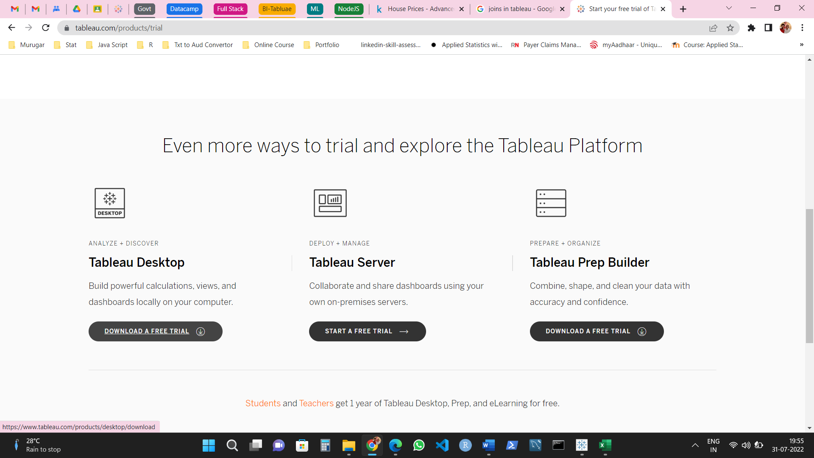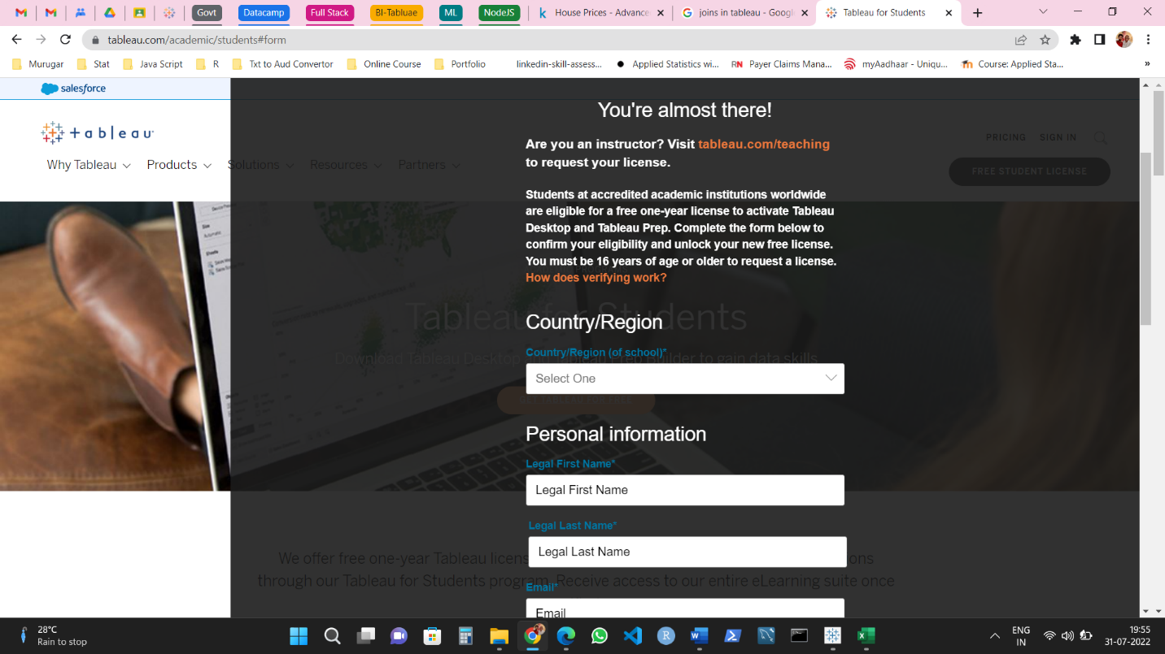

1. Download the data – set (sales – product) from the link:

Establish the connection between tableau and data-set.

Perform left join, right join, cross joins between sales and product data-set

Note the difference between them joins in terms of data – set and visualization and compile them in a word document.

Note: In a word document, compile the screenshot of all the above tasks performed.

